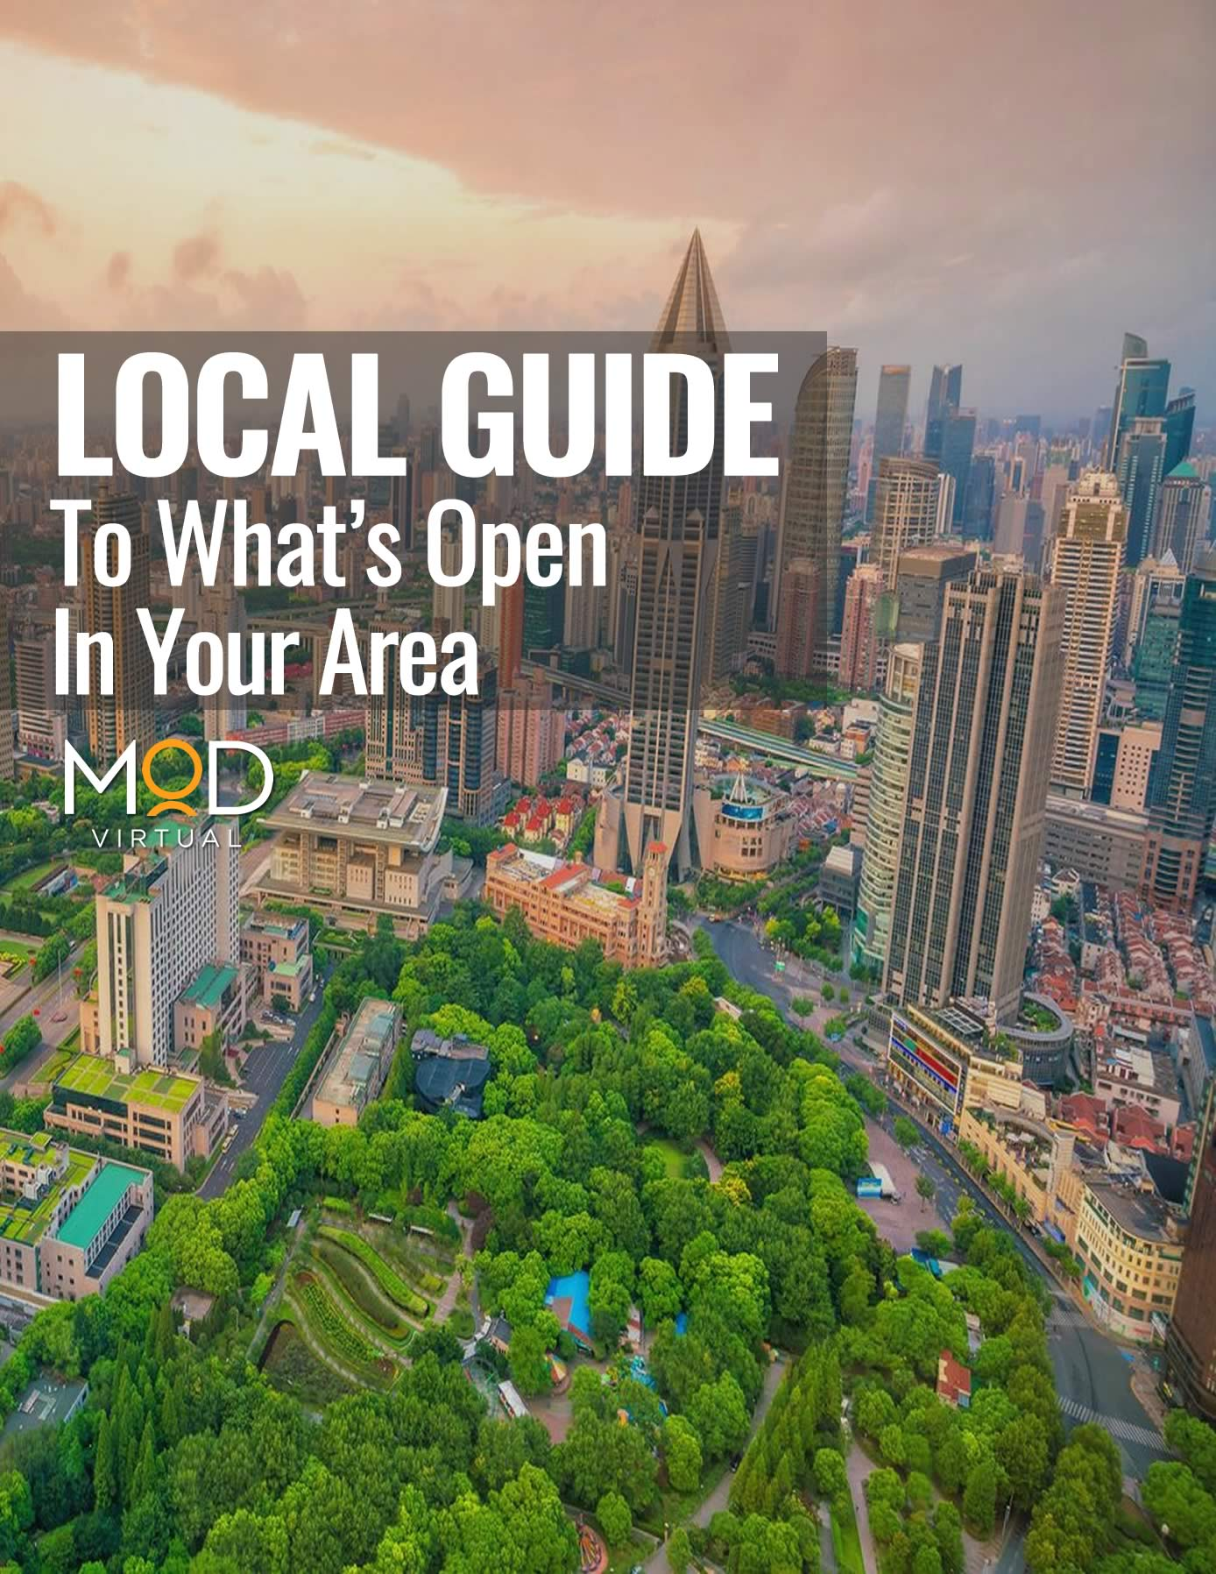

Local Guide to What’s in Your Area

Serve your community, and they will recognize it.
We at MyOutDesk encourage your businesses to show their active support for their local communities amid the COVID-19 crisis. While the economy is experiencing a downturn, business can proactively focus their efforts on building their brand, nurturing relationships, and ultimately being of service.

This guide offers a template for your business to make a useful local guide & directory that you can give, as a pdf or as a link hosted on your website, to your local (online) community groups for immediate use amid the COVID-19 health crisis.
Here’s your how-to for bringing a helpful resource into your community. Read on for:

- An example Local Guide (For Sacramento, California)
- A template for creating a guide to your area
- A distribution checklist

-------------------------------

We at MyOutDesk strive to support the success of all SMBs and want to pass along useful and practical resources that can help your business draw out effective solutions.

Example Local Guide:

LOCAL GUIDE TO SACRAMENTO, CALIFORNIA
Updated: March 24th, 2020
Check these links periodically to stay updated with the information and resources that you need.

🏠 COMMUNITY ESSENTIALS

🏢 Health Authorities & Government Updates:

- Police
- Sherriff
- City
- County
- State
- National
- World Health Organization

🏫 Updates from Local School Districts:

- Sacramento City Unified
- Elk Grove Unified
- Folsom Cordova Unified
- Los Rios Community College District
- Natomas Unified
- San Juan Unified
- Twin Rivers Unified
🚗 What’s open? Essential services remain open, such as:
- Public transit (reduced service)
- Gas stations and auto repair shops
- Pharmacies and big-box retailers
- Food - grocery stores, farmers markets, food banks, convenience stores, take-out and delivery restaurants
- Banks, Pharmacies, Hardware stores
- Shipping and mailing
- Laundromats/laundry services
- Essential state and local government functions also remain open, including law enforcement and offices that provide government programs and services.
🛒 Grocery Store Services:
Here’s a list of grocery stores offering special accommodations such as curbside pick-up, delivery, and senior/high-risk community member hours. Check your local store for exact hours and most up-to-date information.

Senior Hours

- Sprouts
- Safeway: 7-9 am on Tues. & Thurs.
- Nugget
- Whole Foods: 8-9 am everyday
- Taylors Market: 8-9 am everyday
- Smart & finals: 7:30-8 am everyday
- Dollar General: First hour of opening everyday
- Walmart: First hour of opening everyday

Delivery, Special Programs, and Online Grocery Services
- Raley’s/Bel-Air: senior essentials bags
- Instacart.com offers grocery delivery & pickup services.
- Amazon Prime
- Check your local store’s website for in-house online grocery services
🚫 What’s closed?

- Dine-in only restaurants
- Bars and nightclubs
- Entertainment venues
- Gyms and fitness studios
- Public events and gatherings
- Convention Centers
- Hair and nail salons

📦 Delivery for Medical Supplies:
- Medical Couriers, Inc: open 24 hours - (800) 652-1147
- Check with your local pharmacy & health care provider

🚚 Food courier services mobile apps: Uber Eats, Grub Hub, DoorDash, and Postmates. Download in your phone app store.

🚴 STAYING ACTIVE

Are Parks & Recreations open? Or not? Sacramento City Parks are open. Recreation facilities & events are closed. Learn more about Sacramento City Parks.

Hiking & Biking Areas: Sacramento City Hiking & Biking areas are open. Learn more about Sacramento City Parks.

Online Home-Based Classes: Yoga Seed; Search on Youtube and Google for home workouts.

😊 STAYING ENGAGED
Online Community Boards: Nextdoor.com
Neighborhood Associations: Link
Learning Platforms for Kids:
- Scholastic Learn at Home Program
- Khan Academy
- Outschool
- ABC Mouse
- Family Going Stir Crazy? These Apps Can Help

💼 BUSINESS RESOURCES

Does my community have a Business Economic Stimulus Plan? Sacramento does not at this time. Learn more in the Sacramento Business Journal
SBA Small Business Loans: Federal SBA disaster loan relief may be available.

Setting up for remote work amid a health crisis: Link

90 Day Tax Extension: Link

Your Template: (Don’t forget to add your branding!)

LOCAL GUIDE TO [LOCATION]
Check these links periodically to stay updated with the information and resources that you need.

🏠 COMMUNITY ESSENTIALS

🏢 Health Authorities & Government Updates:

- [Add links]
- Police
- Sherriff
- City
- County
- State
- National
- World Health Organization

🏫 Updates from Local School Districts:

- [Links to local school districts’ COVID-19 pages]
🚗 What’s open? Essential services remain open, such as:
- [Add/edit list of available local services, and add relevant links]
- Public transit (reduced service)
- Gas stations and auto repair shops
- Pharmacies and big-box retailers
- Food - grocery stores, farmers markets, food banks, convenience stores, take-out and delivery restaurants
- Banks, Pharmacies, Hardware stores
- Shipping and mailing
- Laundromats/laundry services
- Essential state and local government functions also remain open, including law enforcement and offices that provide government programs and services.
🛒 Grocery Store Services:
Here’s a list of grocery stores offering special accommodations such as curbside pick-up, delivery, and senior/high-risk community member hours. Check your local store for exact hours and most up-to-date information.

Senior Hours

- [Add/edit list of available local services, and add relevant links]

Delivery, Special Programs, and Online Grocery Services
- [Add/edit list of available local services]
- Instacart.com offers grocery delivery & pickup services.
- Amazon Prime
- Check your local store’s website for in-house online grocery services
🚫 What’s closed?

- Dine-in only restaurants
- Bars and nightclubs
- Entertainment venues
- Gyms and fitness studios
- Public events and gatherings
- Convention Centers
- Hair and nail salons

📦 Delivery for Medical Supplies:
- Medical Couriers, Inc: open 24 hours - (800) 652-1147
- Check with your local pharmacy & health care provider

🚚 Food courier services mobile apps: Uber Eats, Grub Hub, DoorDash, and Postmates. Download in your phone app store.

🚴 STAYING ACTIVE

Are Parks & Recreations open? Or not? [Add info]

Hiking & Biking Areas: [Add info]

Online Home-Based Classes: [Add local offerings]; Search on Youtube and Google for home workouts.

😊 STAYING ENGAGED
Online Community Board: Nextdoor.com
Neighborhood Associations: [Link to Neighborhood Association Directory]
Learning Platforms for Kids:
- Scholastic Learn at Home Program
- Khan Academy
- Outschool
- ABC Mouse
- Family Going Stir Crazy? These Apps Can Help

💼 BUSINESS RESOURCES

Does my community have a Business Economic Stimulus Plan? [Add info]
SBA Small Business Loans: Federal SBA disaster loan relief may be available.

Setting up for remote work amid a health crisis: Link

90 Day Tax Extension: Link
-------------------------------

DISTRIBUTION CHECKLIST

Sample Message: We at [Business Name] encourage your active preparedness, and so to make things easier, we want to give you a timely resource. We would like to offer the community a timely Local Guide to [City]: What’s Open in Our Community. We pray that your team, families, and our communities remain safe and healthy during this time of heightened concern. Stay safe!

Distribute your Local Guide to the following audiences.

- All local community groups in Facebook
- Local Nextdoor.com community group
- Chambers of commerce
- Neighborhood associations
- Local Rotary, Kiwanis, and other volunteer organizations
- Local professional networks
- Your contact lists
- Community boards
- Public posting boards

-------------------------------

GO REMOTE
MyOutDesk’s origin story is set during the last global financial crisis of 2008. Yes, that’s right — we have 13 years of experience and over 5,000 clients. Our specialists will help you design an action strategy for remote growth & cost-reduction in your business. Go remote today!

